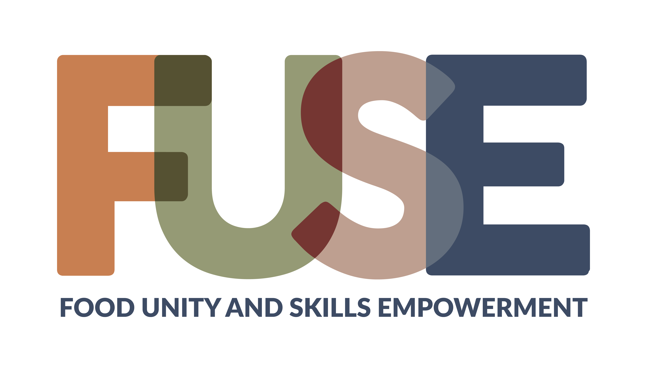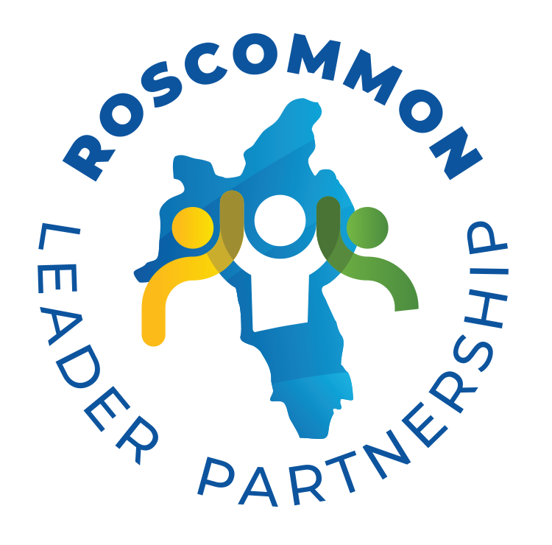
Free food sector training for adults out of paid work for 12 months or more.

Brought to you by

Participant application form
Apply by 13th November 2026 |Training starts 25th November 2026

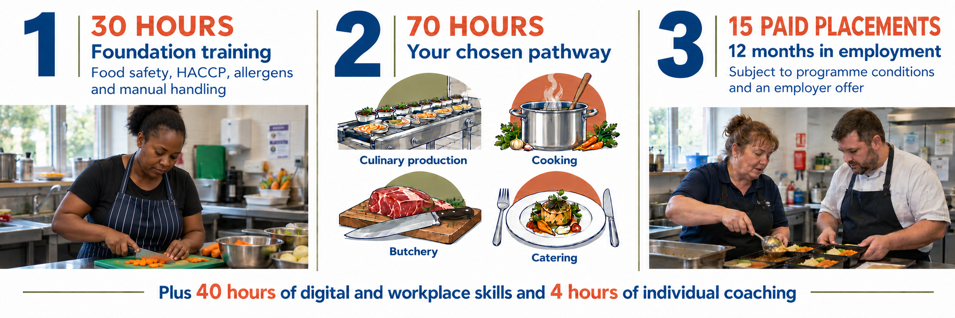
- The Foundation of 30 hours spread across 7 days over 2 weeks, usually 10am to 3pm. Final day ends at 1.30pm. Includes 30 minutes of breaks each day.
- Pick a pathway for specific training in key areas and complete 70 hours of practical training
- 15 people will have the chance for a 12 month paid work placement with an employer

Complete this form, save a copy and email it to hello@foodenterprise.zone
You can apply with help by telephone or in person. Our team will explain the next steps.

Full name | Preferred name (optional)
Telephone | Email
Town / local area | How did you hear about FUSE? (optional)

Please provide a telephone number or email address so we can contact you.

How would you like us to contact you?
☐ Telephone ☐ Text message ☐ Email

Preferred venue (Delivery at each venue is subject to numbers and availability)
☐ The Food Hub, Drumshanbo, Co. Leitrim ☐ An Chistin, Castlerea, Co. Roscommon


☐ I would like to discuss support or arrangements for taking part. Your answers help us plan learning and support with you. You can ask for help or choose to discuss a question privately with our team. Our team can discuss access, travel, language, digital or caring needs with you.

Which pathways interest you? Select any, or ask us to help you choose.
☐ Culinary production ☐ Cooking ☐ Butchery☐ Catering ☐ Help me choose

1. Education and learning
Tell us about any school, college, training or certificates you have completed.

Include learning completed in Ireland or another country. Brief answers are welcome.

2. Skills and confidence
For each area, choose the answer that suits you today.
Area | Confident | Some support | Discuss privately
Reading and following instructions | ☐ | ☐ | ☐
Everyday numbers and measuring | ☐ | ☐ | ☐
Using a phone or computer | ☐ | ☐ | ☐
Communicating during training | ☐ | ☐ | ☐

3. Work and other experience
Paid work, volunteering, caring, home cooking or other useful experience

How long have you been away from paid work?

4. Your food experience
Tell us about any experience with food. Home cooking, baking, preparing meals for others, volunteering and paid food work all count.
What have you done, and which food tasks do you enjoy?

You can also write “I am new to this” or ask us to help you describe your experience.

5. Benefits or support payments (optional)
Any benefits or payments you receive, or write “Discuss privately”.

We can discuss how taking part may relate to your payments.

6. Support needs and barriers to taking part (optional)
Travel, caring, timings, language, access, learning or other needs

Brief practical information is enough. You can also write “Discuss privately”.

7. How did you hear about FUSE?



